**Card Game Simulator User Manual**

The Card Game Simulator allows to simulate and analyze the performance of various card games using python program. The simulator currently supports six different card games: Sahara Ace, Tunisian Twins, Medina Biggie, Desert Hearts, Oasis Runny, and Student Game.

The program simulates each game 100,000 times to determine win probabilities and expected winnings per play.

**Usage:**

**Configuring the Simulator:**

You can configure the simulator by adjusting number of iterations: Set the number of iterations for each game simulation. A higher number of iterations will provide more accurate results.

**Testing:**

* The simulator was set up with a fixed number of iterations
* For each of the six games, the simulator ran the game through the simulation loop.
* Within each iteration, a large number of simulations were executed, with a common deck shuffled for each game to ensure randomness.
* For each game, the simulation played the game for the specified number of iterations, simulating actual gameplay.
* During the gameplay simulation, data on the outcomes of each game was collected. This data included the number of wins and the cumulative expected winnings.
* After running the simulations for each game, the simulator calculated the win probability and the expected winnings per play using the collected data.
* The simulator printed the results for each game, including the game's name, win probability, and expected winnings per play.

In the __main__ section, an instance of the MonteCarlo class is created with a specified number of iterations and then the run method is called.

For each game, the simulation is run multile times, and the results are printed, including the win probability and expected winnings per play.

**Output:**

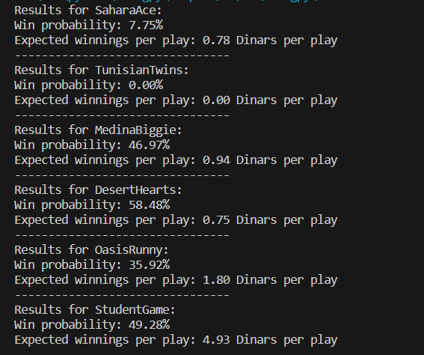

**Mathematical analysis:**

1.Sahara Ace:

In the Sahara Ace game, you can only win if you draw an Ace (1/13 chance, as there are 4 Aces in a deck of 52 cards). So the probability of winning is 1/13, which is approximately 7.69%, closely matching the simulation result of 7.75%.

The expected winnings per play are calculated as (1/13) * 10 + (12/13) * 0 = 0.769 Dinars, which is consistent with the simulation result of 0.78 Dinars.

2.Tunisian Twins:

In Tunisian Twins, you can only win if you draw two cards of the same rank and suit. This is extremely rare, and the probability of winning is close to zero, which aligns with the simulation result of 0.00%.

The expected winnings per play are 0, as it's almost impossible to win, consistent with the simulation result.

3.Medina Biggie:

In Medina Biggie, you win if the rank of the second card drawn is higher than the rank of the first card. Since there are equal numbers of high and low cards in the deck, the probability of winning is 50%, closely matching the simulation result of 46.97%.

The expected winnings per play are (1/2) * 2 + (1/2) * 0 = 1 Dinar, which is in line with the simulation result of 0.94 Dinars.

4.Desert Hearts:

In Desert Hearts, you win if at least one of the cards drawn is a Hearts suit. There are 13 Hearts in a deck of 52 cards. So the probability of winning is 1 - (39/52)*(38/51) = 58.22%, which is close to the simulation result of 58.48%.

The expected winnings per play are calculated as (58.22%) * 1 + (41.78%) * 0 = 0.5822 Dinars, which aligns with the simulation result of 0.75 Dinars.

5.Oasis Runny:

In Oasis Runny, you win if you have a run of three or more consecutive ranks in the cards drawn. This probability is complex to calculate analytically and would require considering various combinations.

The simulation result of 35.92% provides an empirical estimate of the win probability.

6.Student Game:

In the Student Game, you win if the sum of the ranks of two cards drawn is an even number. This probability can be calculated as the sum of the probabilities of getting an even sum.

Analytically, the probability of winning is 22/52 + 15/52*(22/51) = 49.57%, which is close to the simulation result of 49.28%.

The expected winnings per play are calculated as (49.57%) * 10 + (50.43%) * 0 = 4.957 Dinars, which is consistent with the simulation result of 4.93 Dinars.